DIGITAL CMOS ASSIGNMENT-5:EE25MTECH11009
TSPC schematic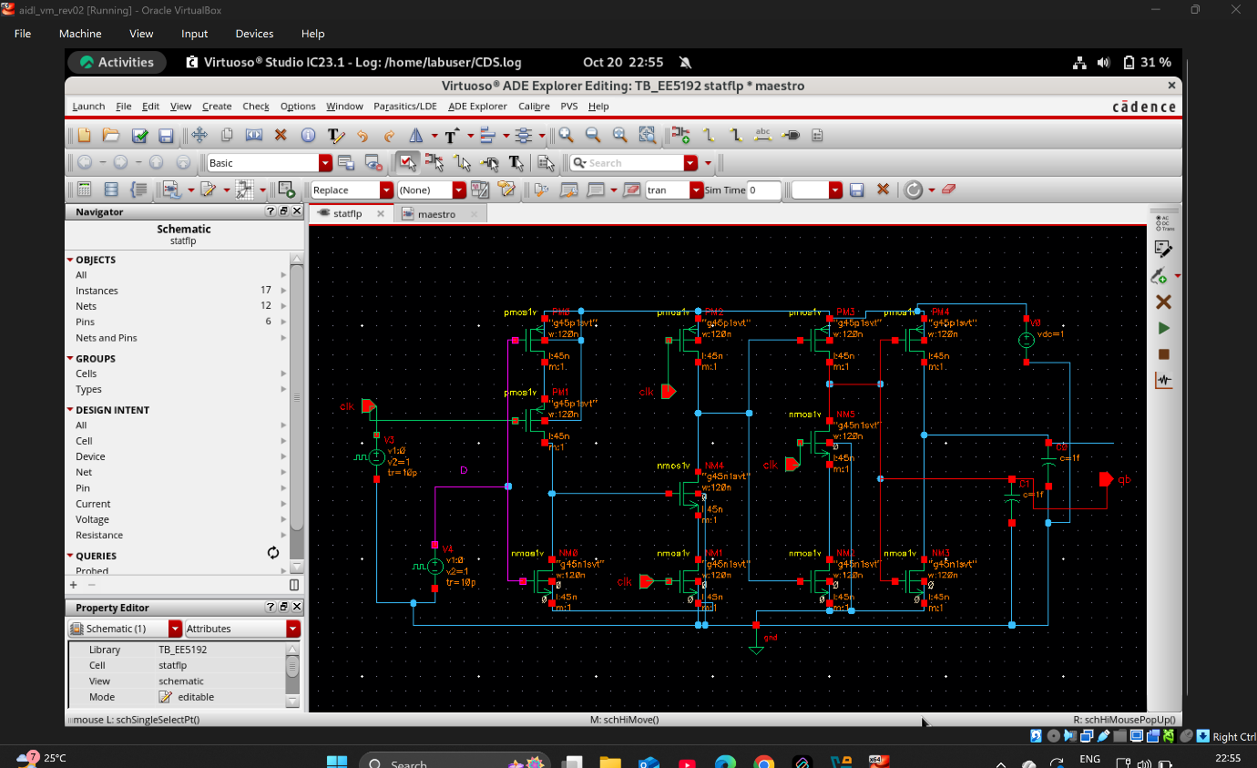
Waveform wrt TSPC
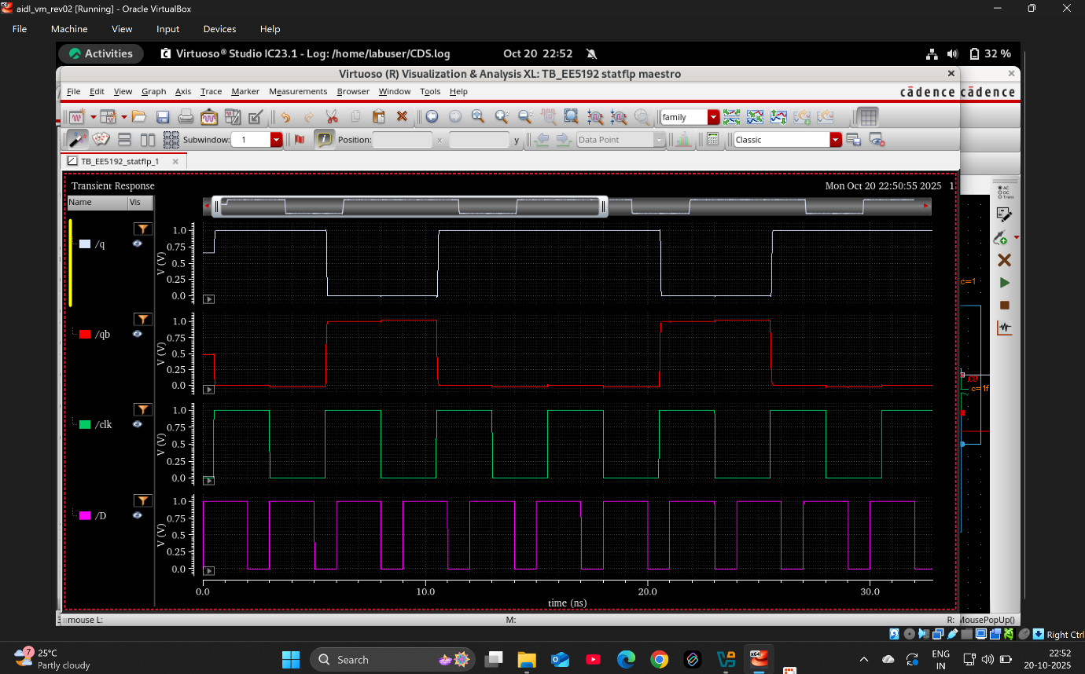

Dynamic with transmission gates
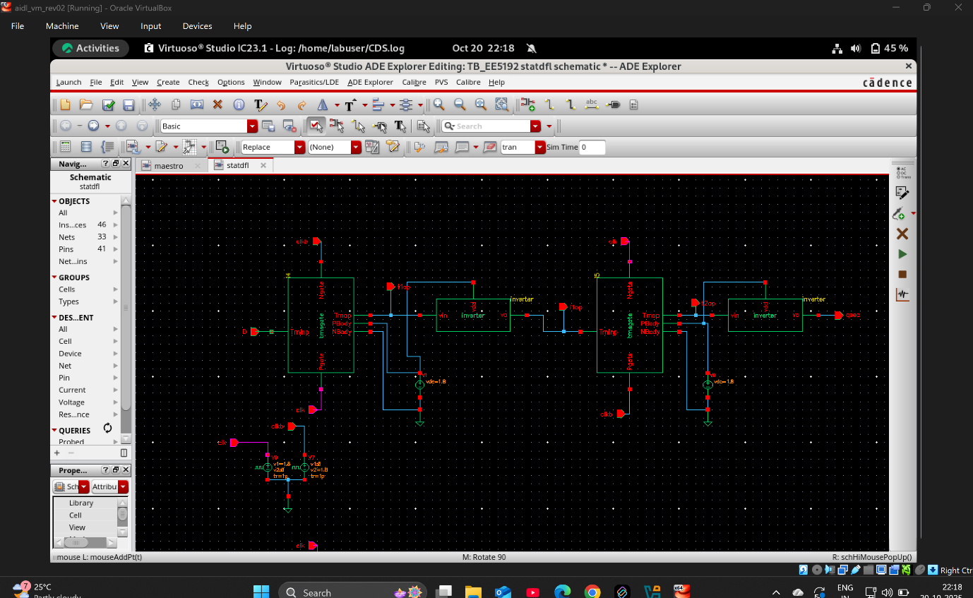

Waveform of dynamic flipflop with transmission gates
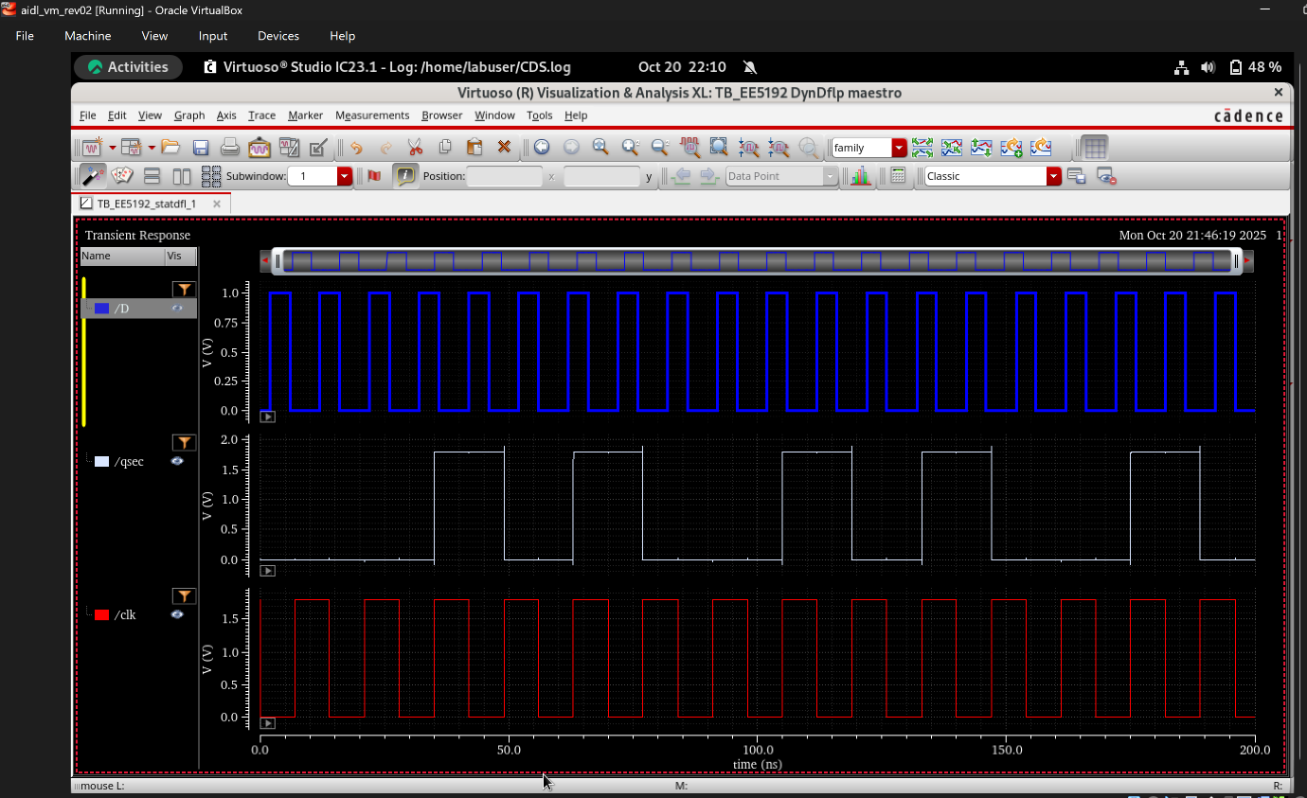

Static D flipflop
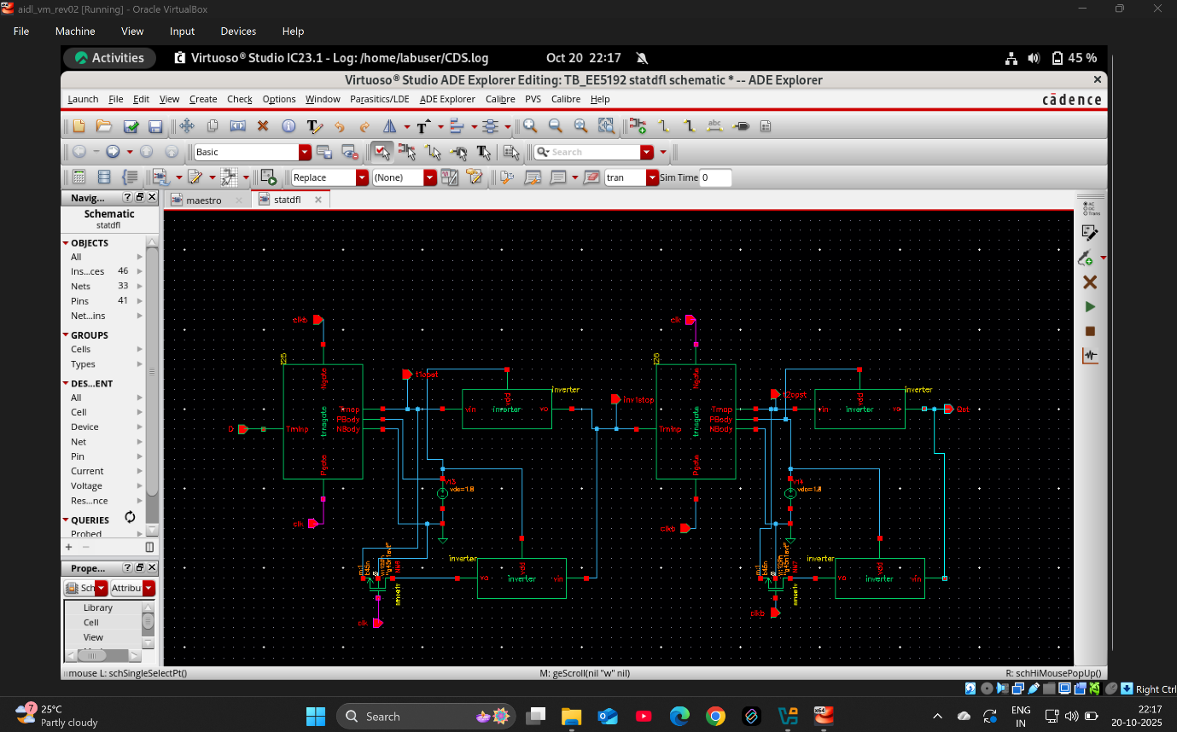
Waveform wrt Static D flipflop
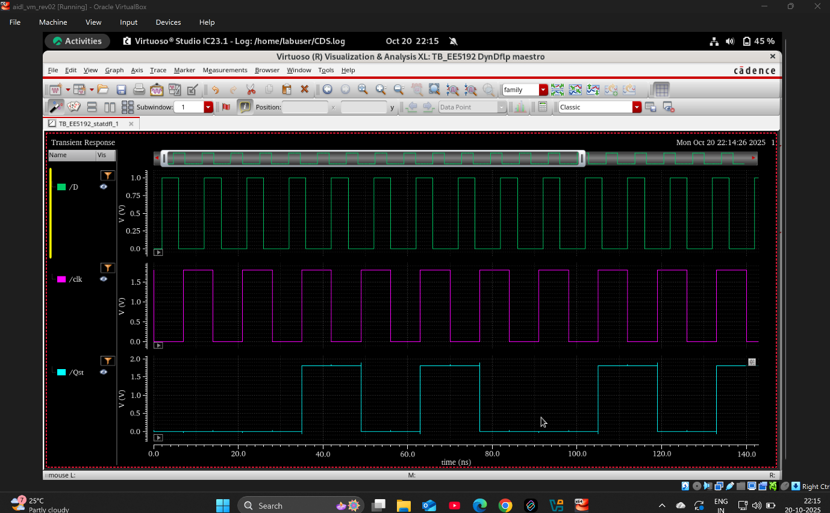

Propagation delay
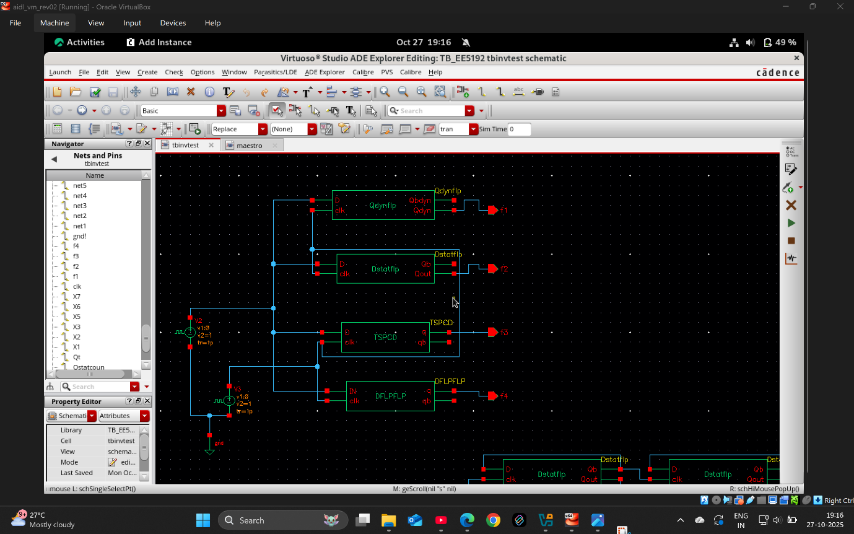
Delay corresponding dynamic flipflop with transmission gates
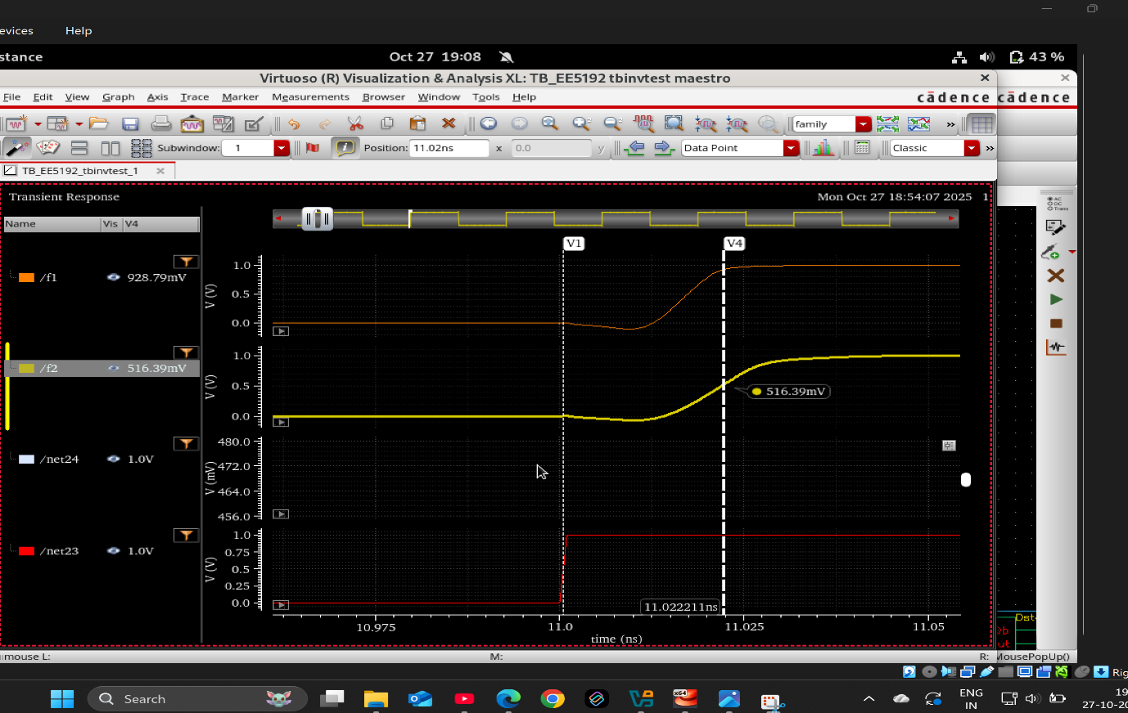
(11.022211-11.000524) ns = 0.021687ns

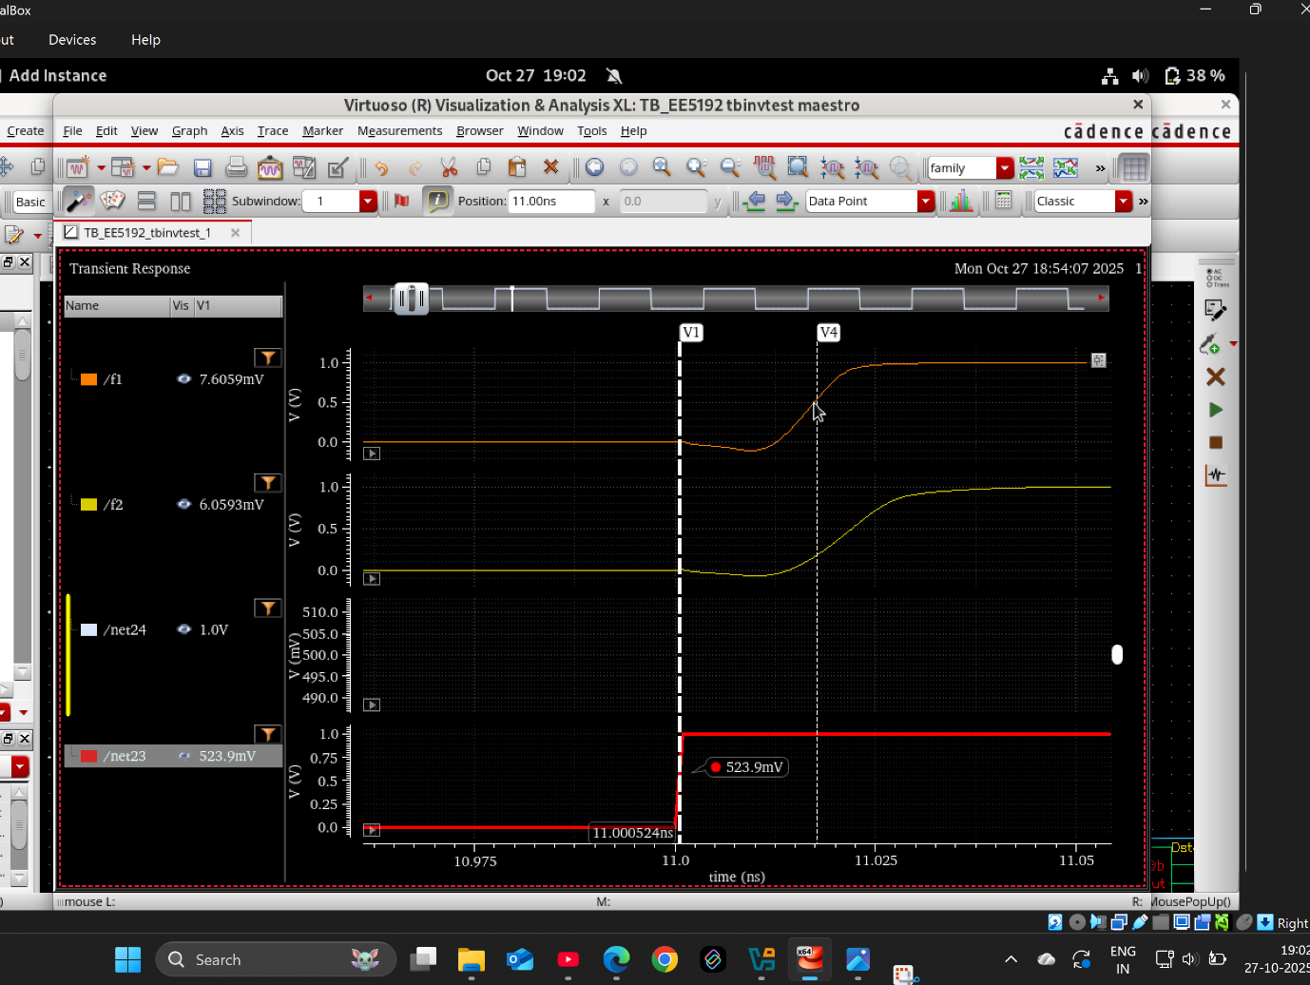
Delay corresponding static flipflop
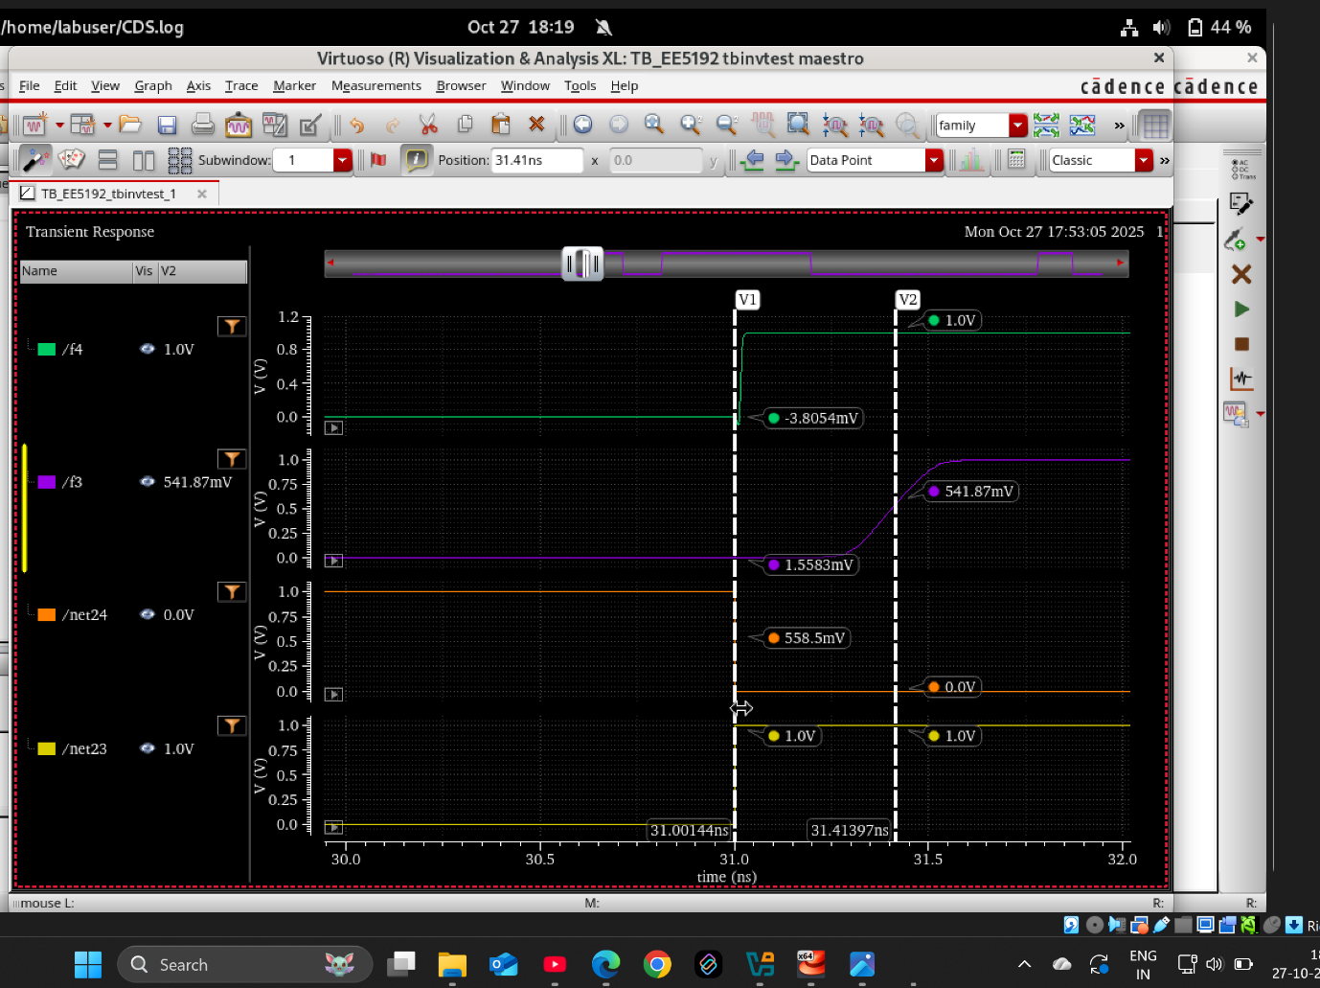
(31.41397-31.00144) ns=0.41253 ns
Setup time
Wrt dynamic with transmission gates
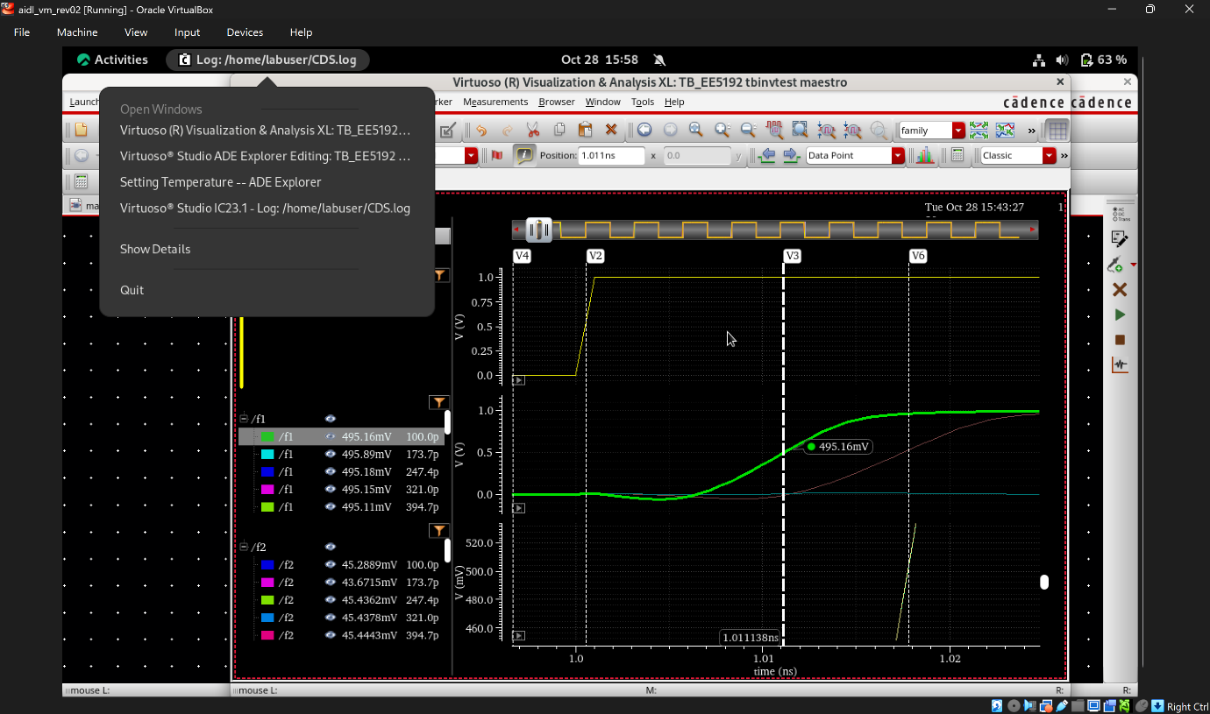

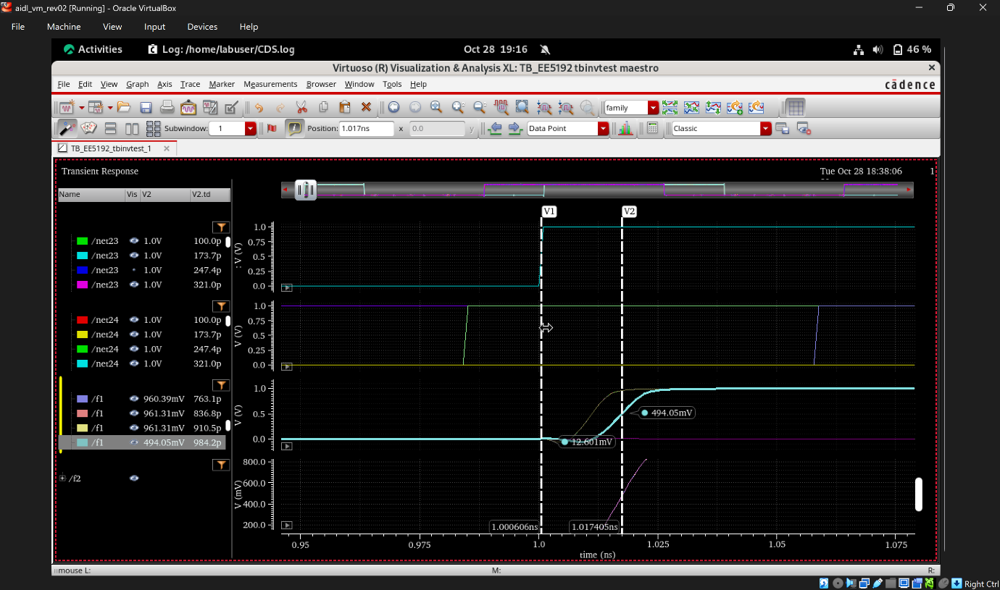
(1-0.9842) ns= 0.0158 ns
Wrt static d flipflop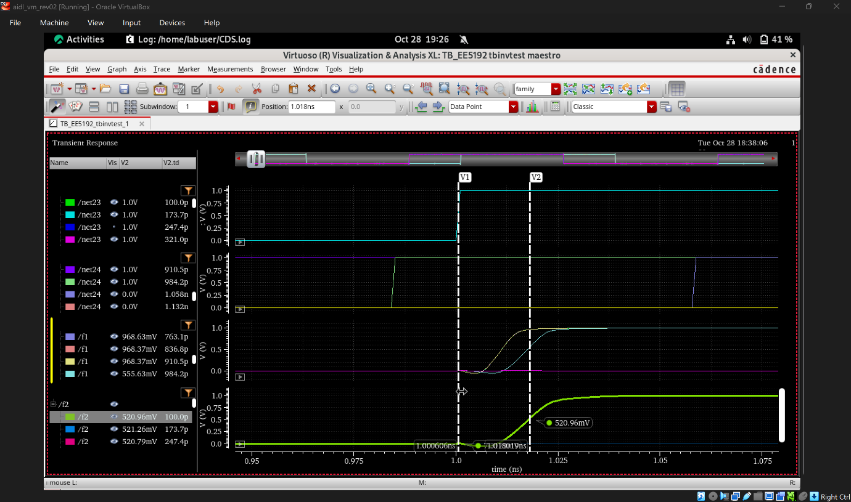
(1-0.9842) ns= 0.0158 ns

Hold time
Wrt dynamic transmission gates
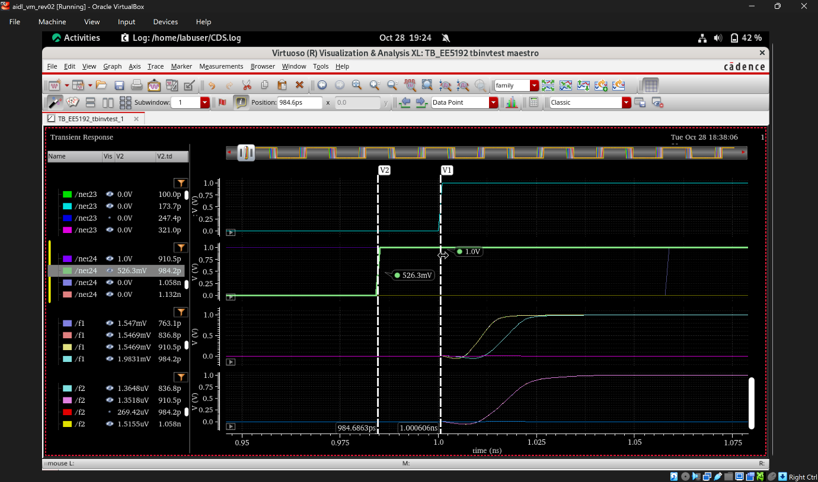

Wrt static d dlipflop
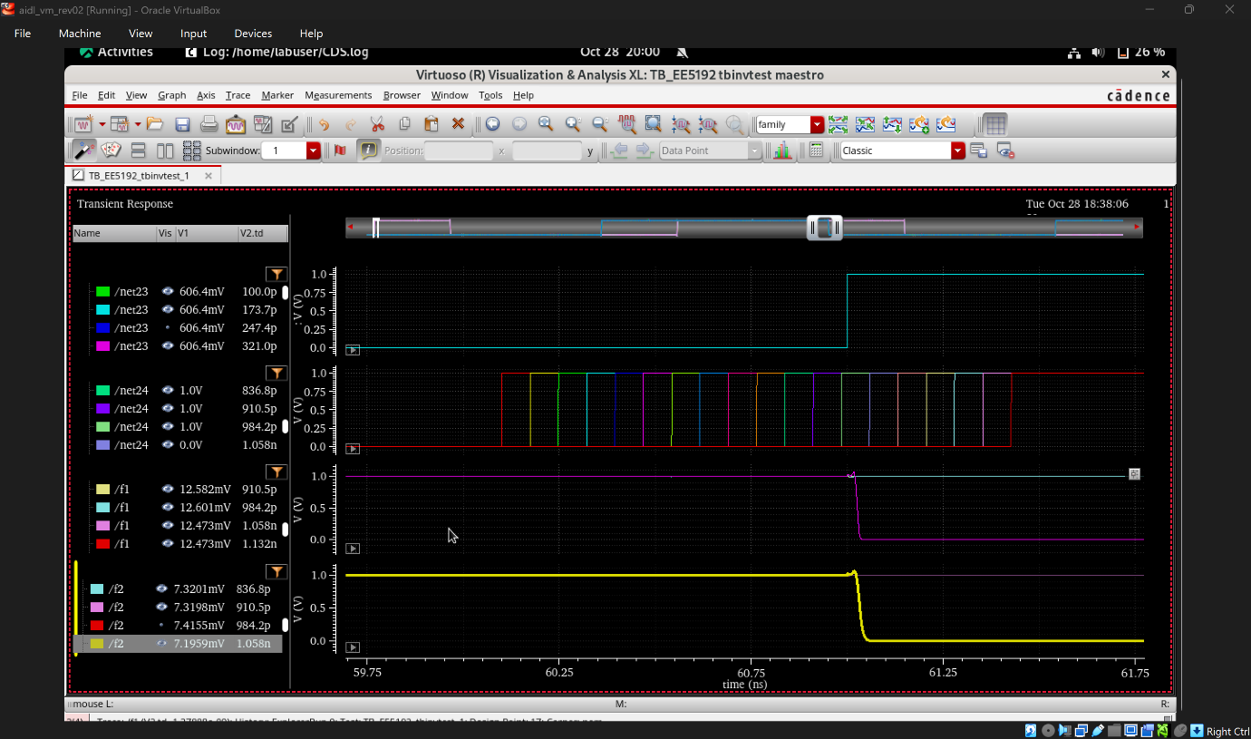

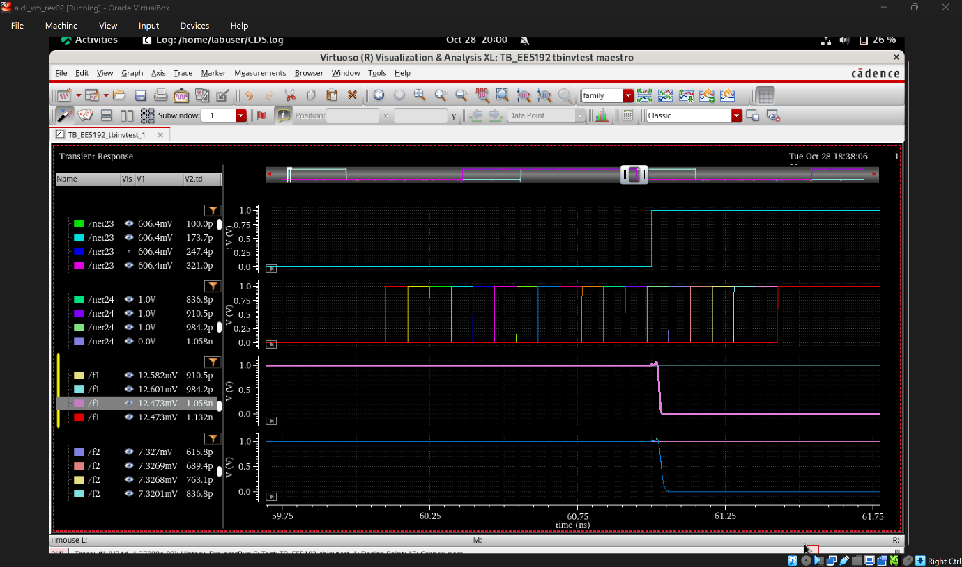

Wrt TSPC D FLIP FLOP
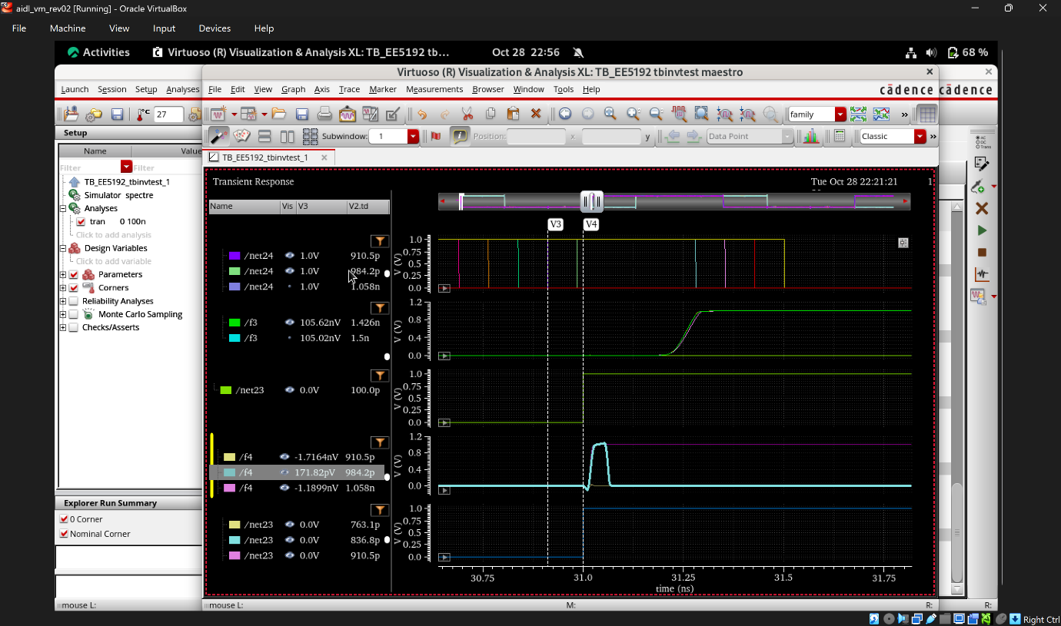

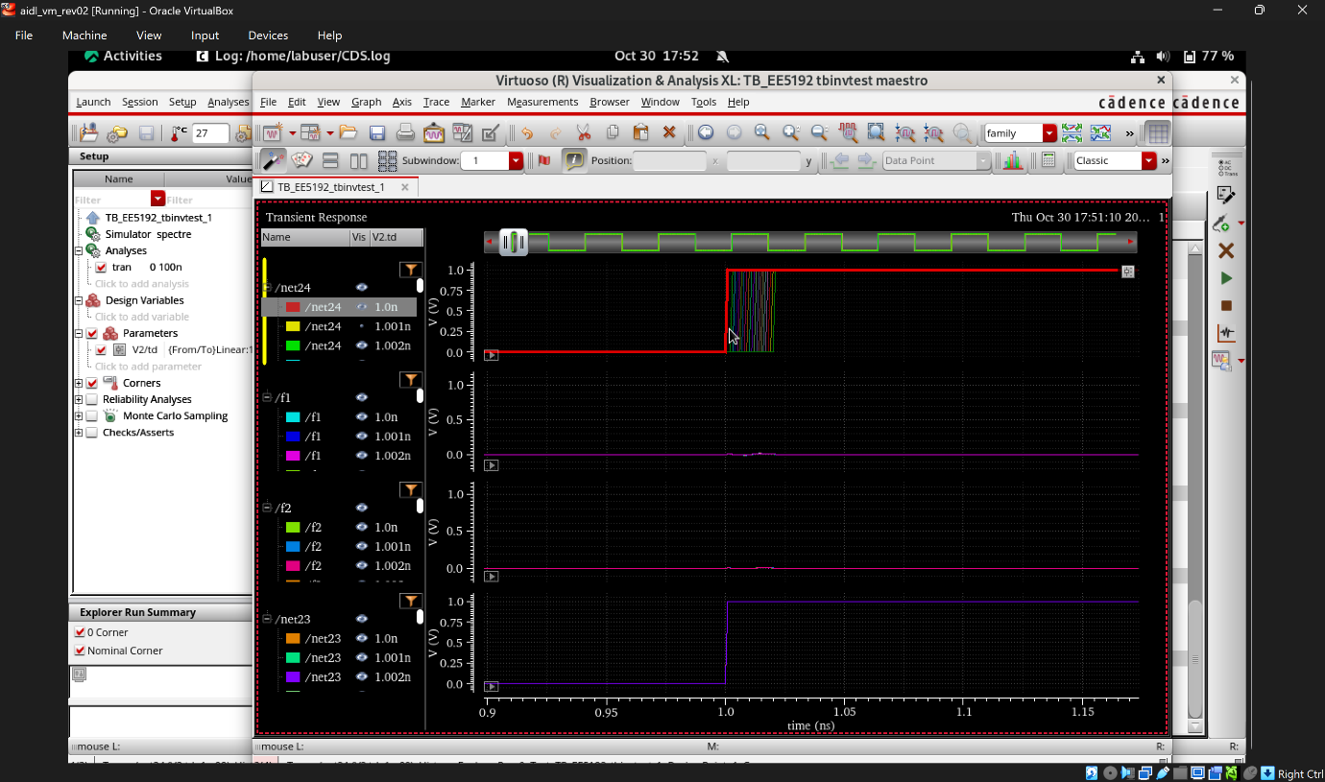

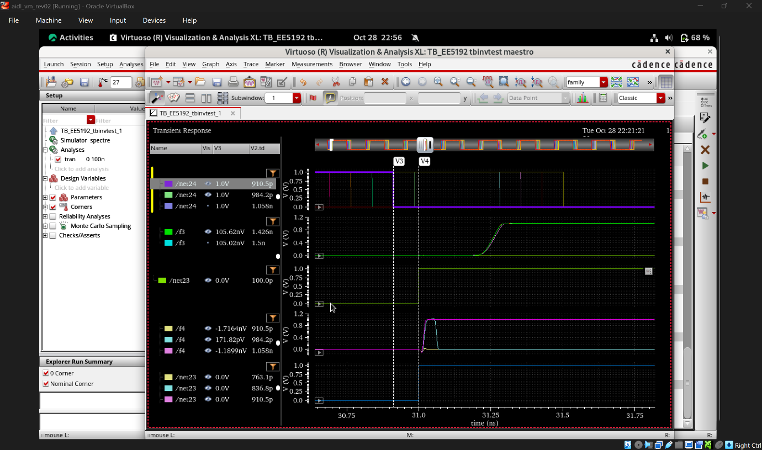

Hence the hold time of above static and dynamic flipflops = 0ns

8bit register using TSPC
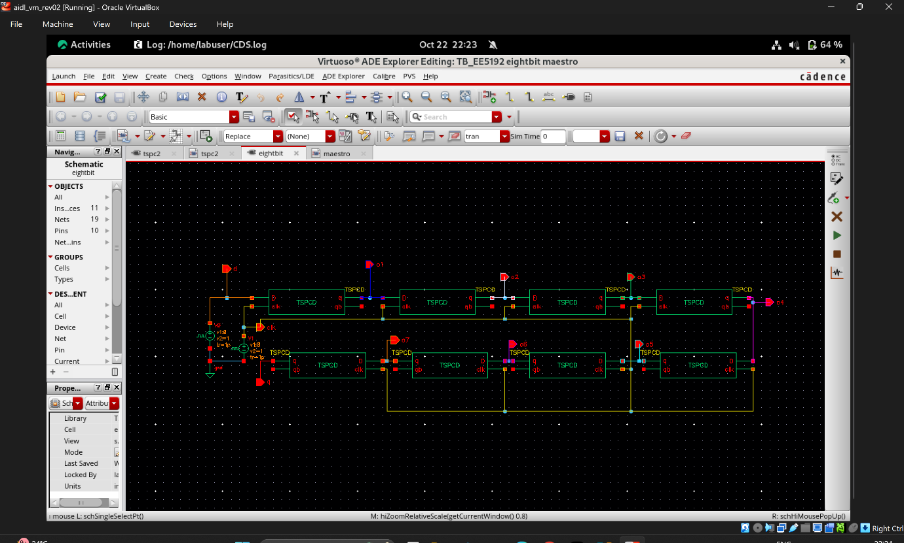

Waveform wrt above schematic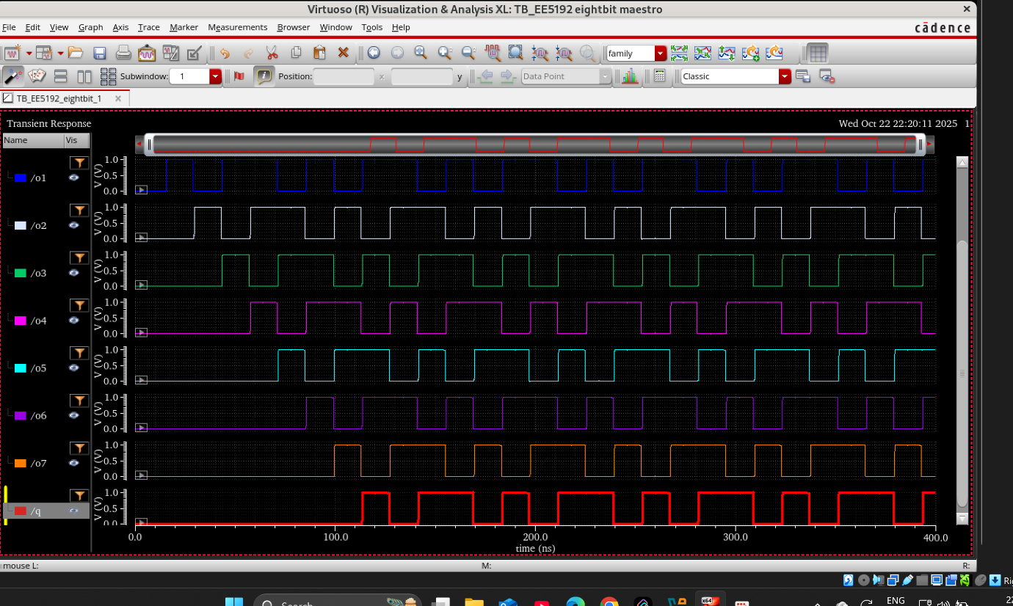

Using static flipflop and Dynamic clock skew
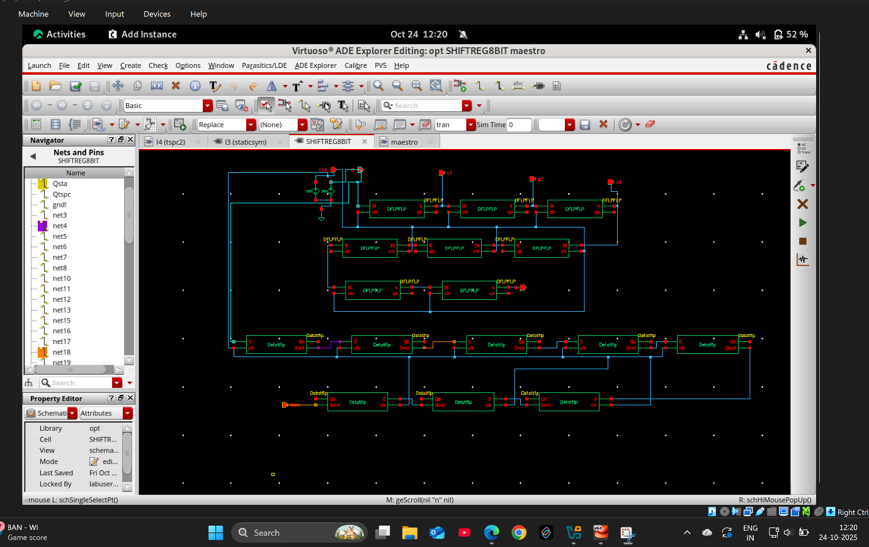
WRT dynamic d flipflop
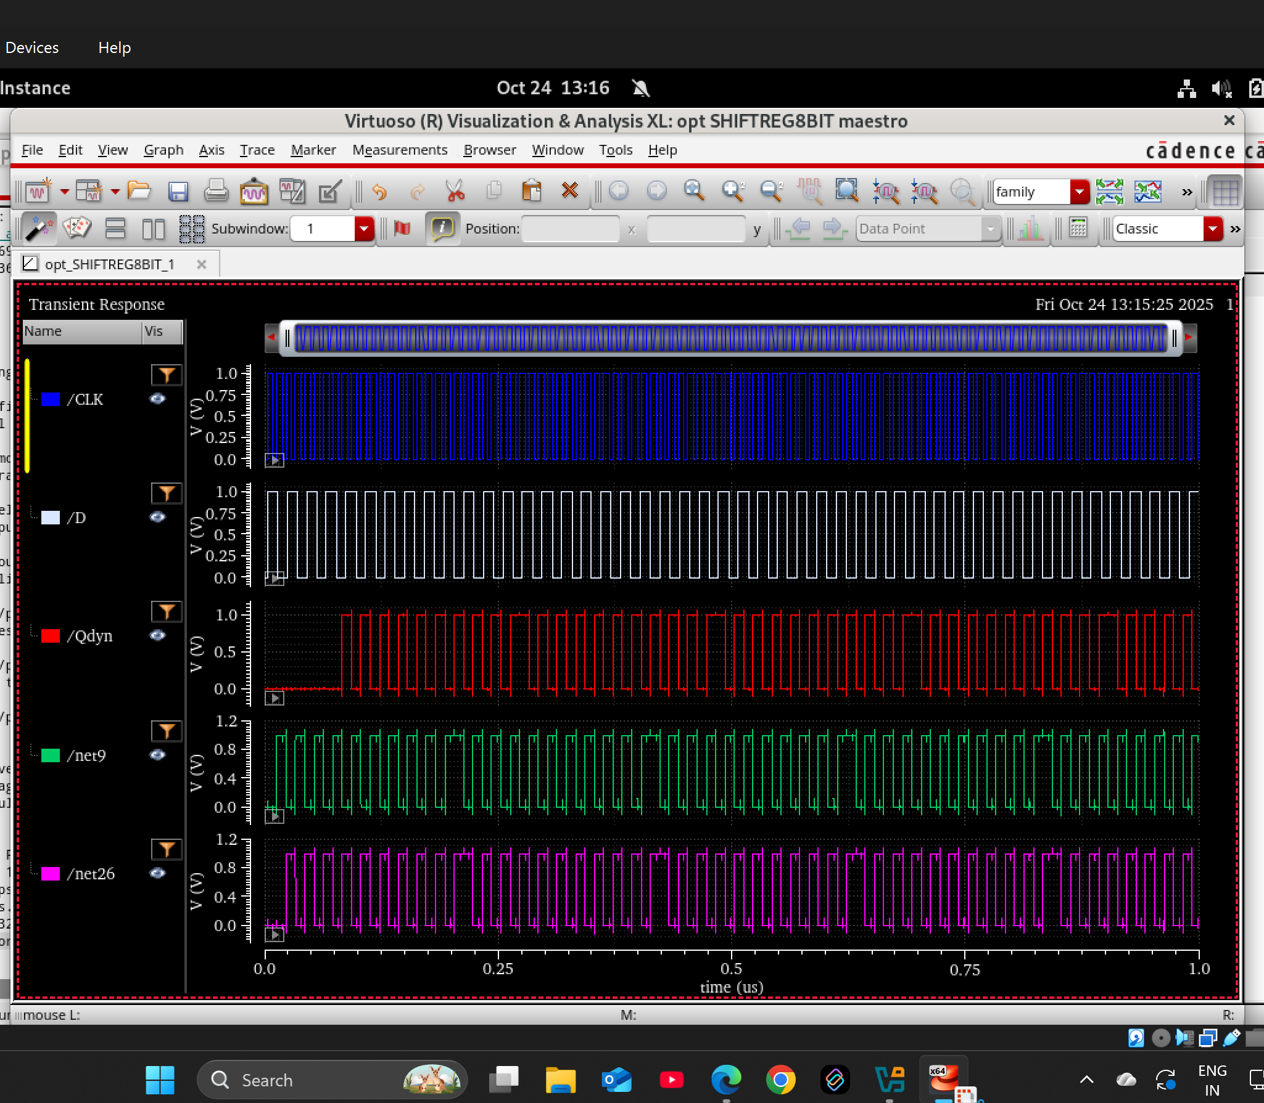
Synchronous counter
Using static flipflop
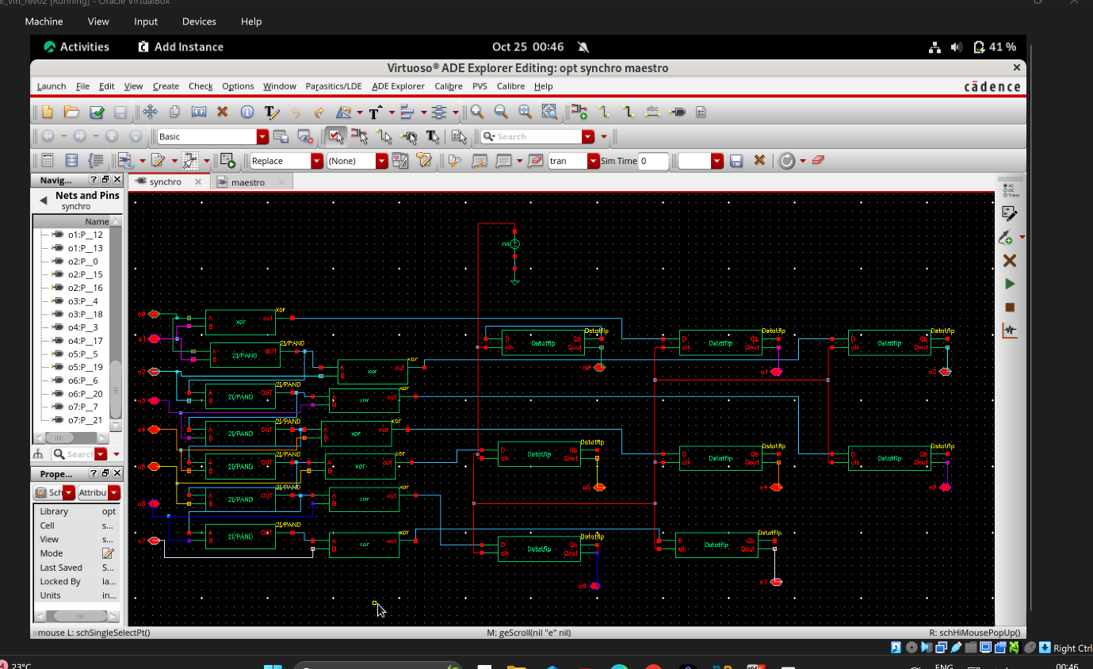
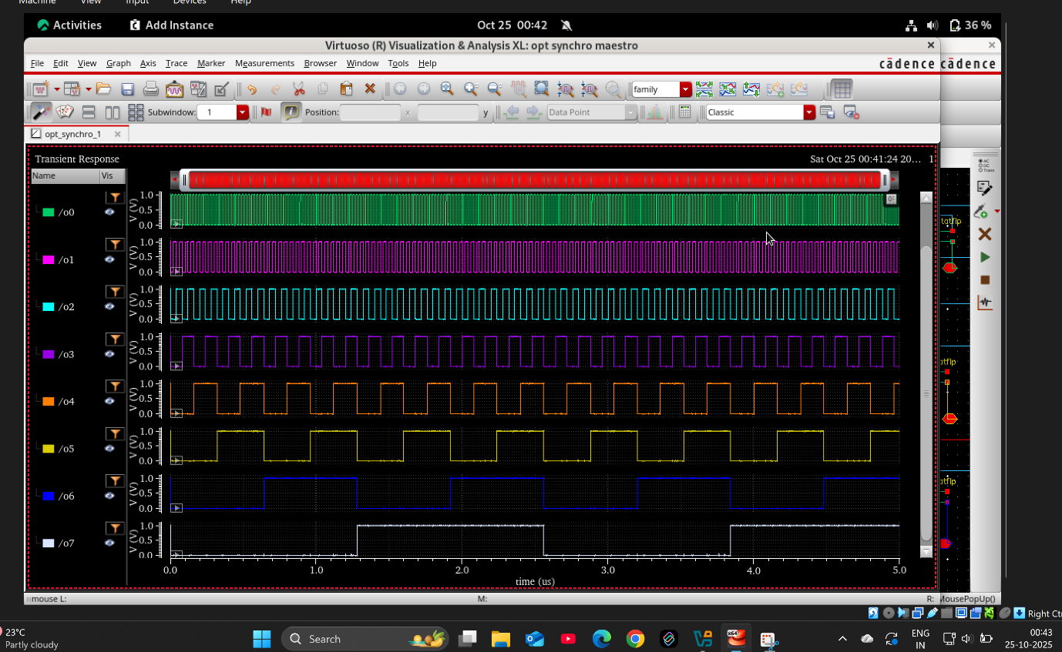

Using dynamic flipflpop
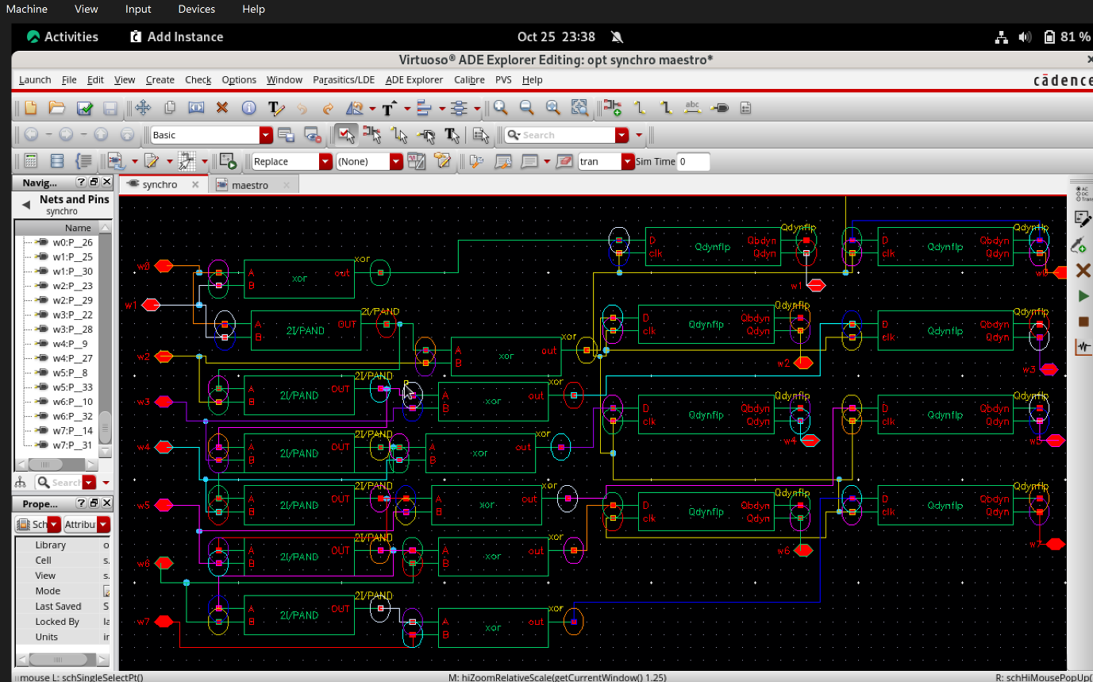
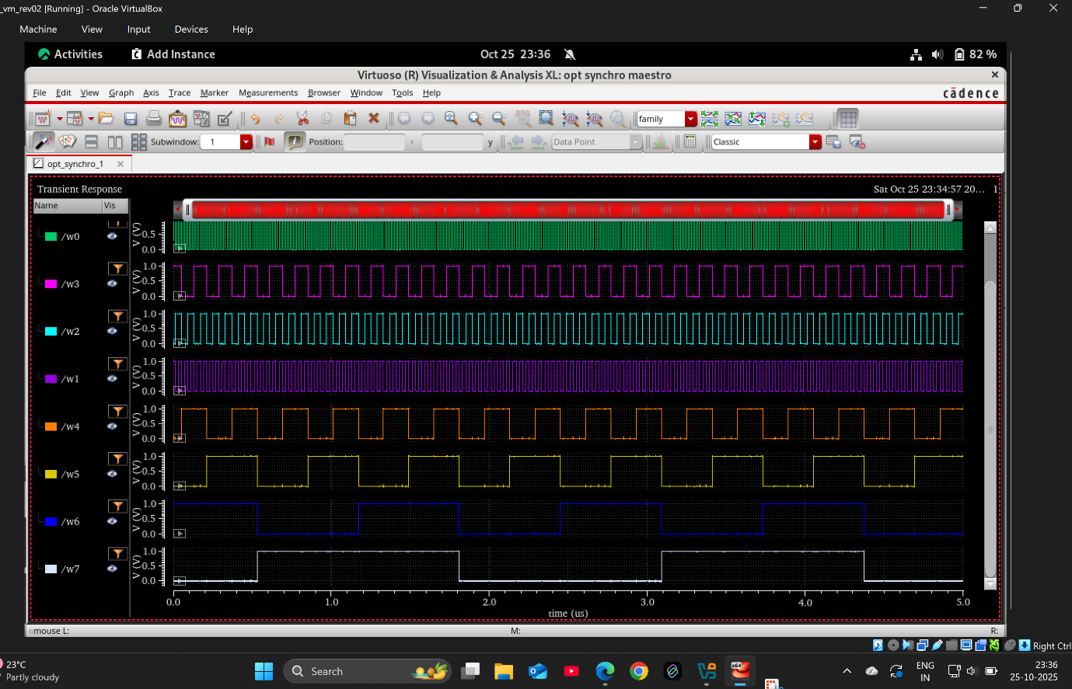

Using tspc flipflop
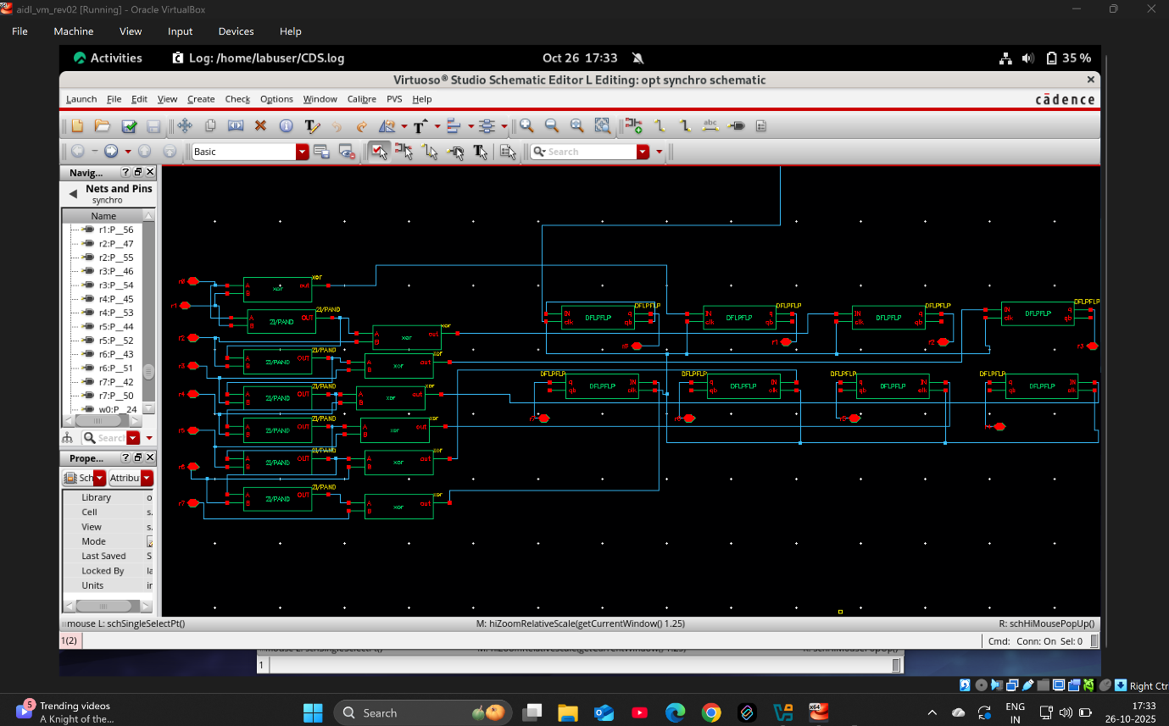

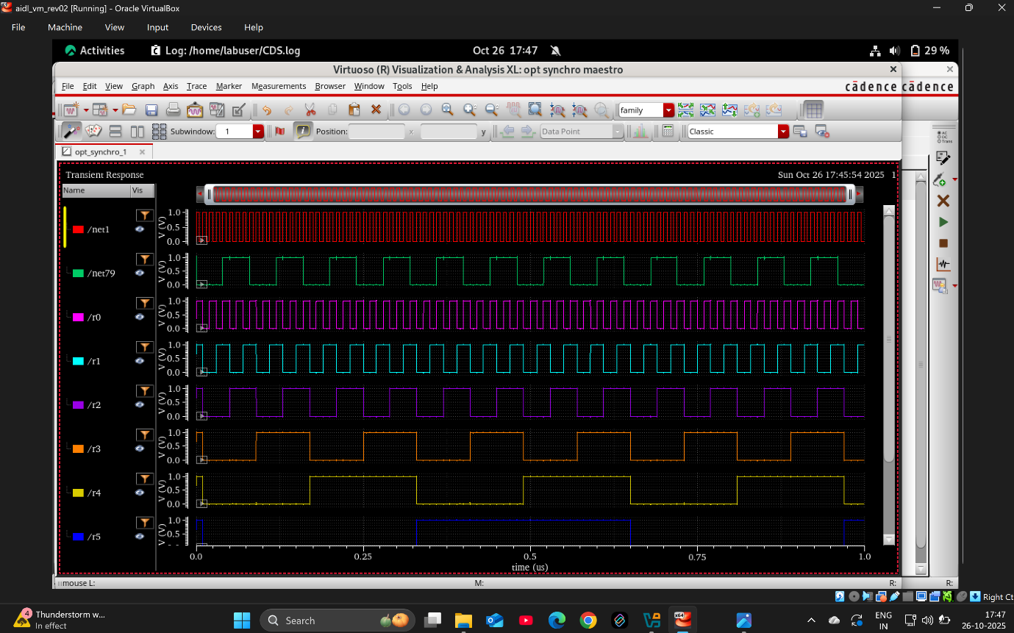
To count maximum frequency

Wrt TSPC
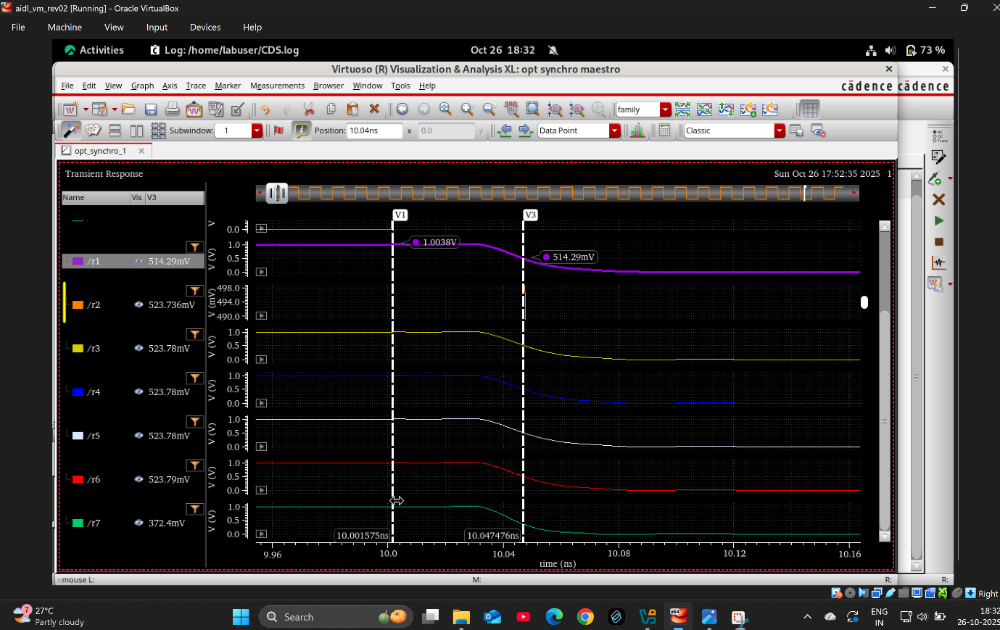
10.047476-10.001575=0.045901ns=21.78GHZ

WRT static flipflop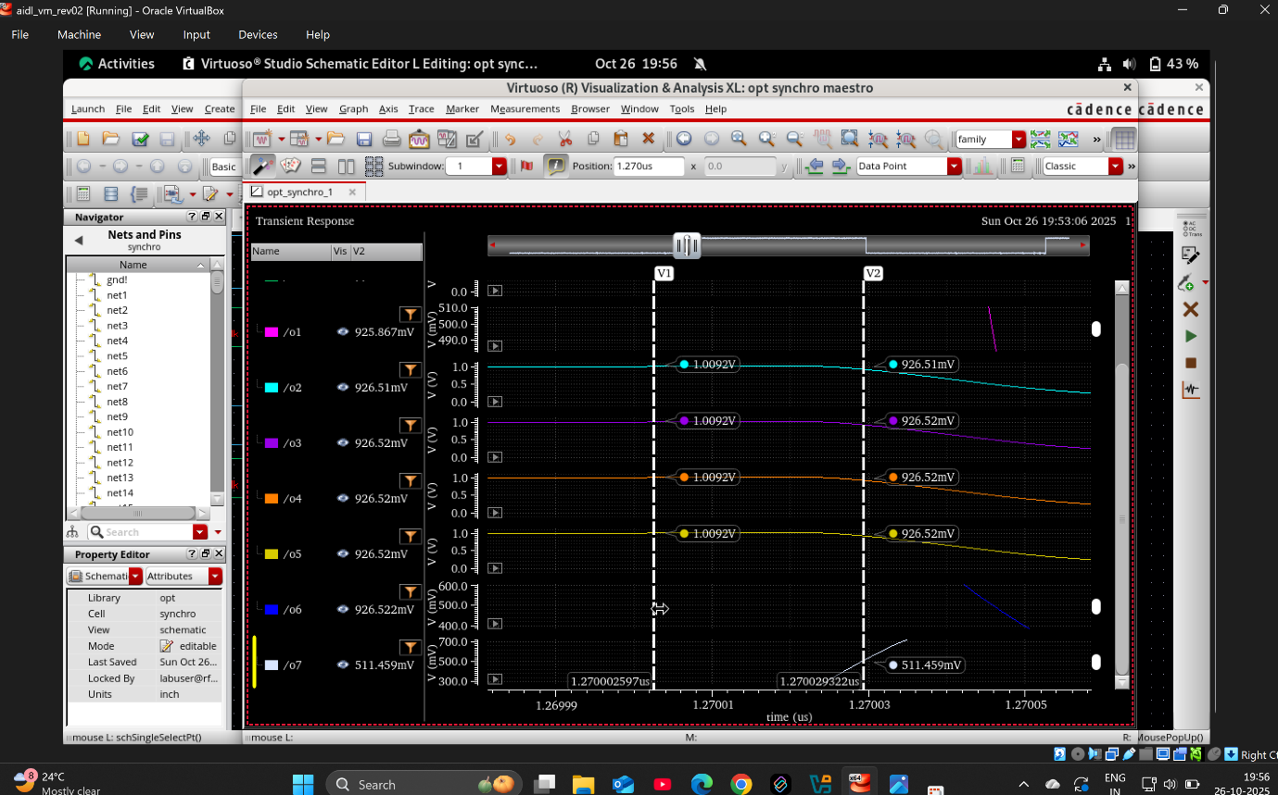
(1.270029322-1.270002597)uS=37.418GHZ
Wrt dynamic flipflop
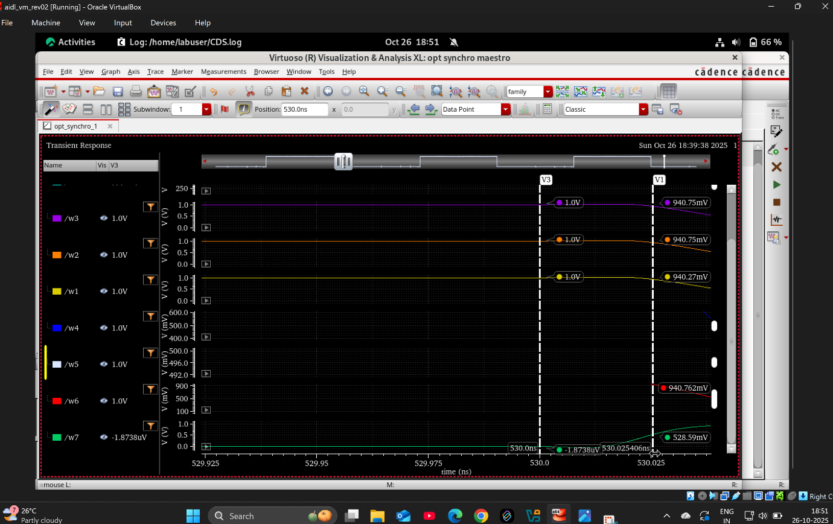
(530.025-530)ns=0.025ns=40GHZ

Asynchronous counter
Using Static flipflop
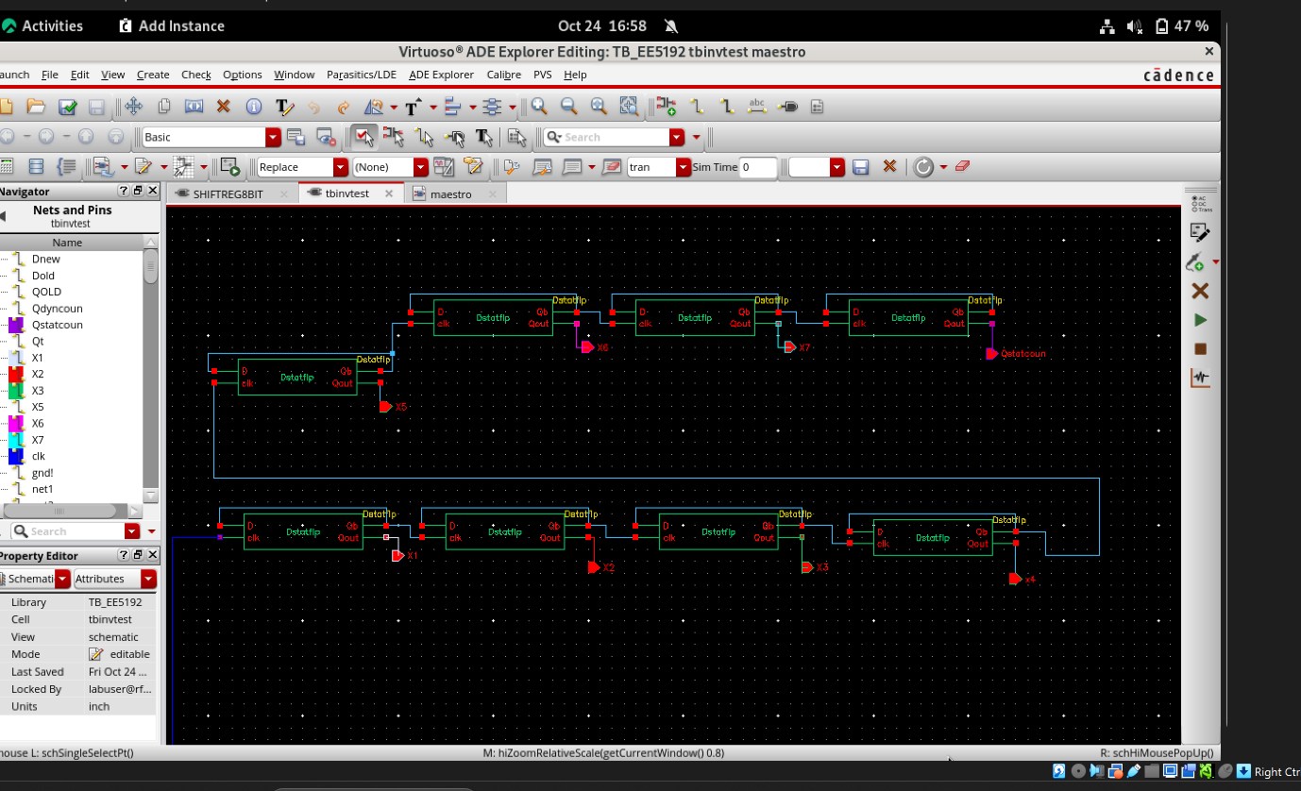
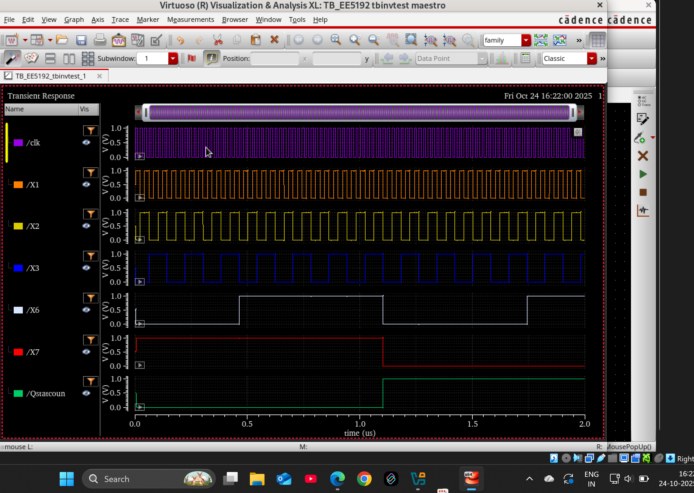

Using dynamic flipflop clock insensitive
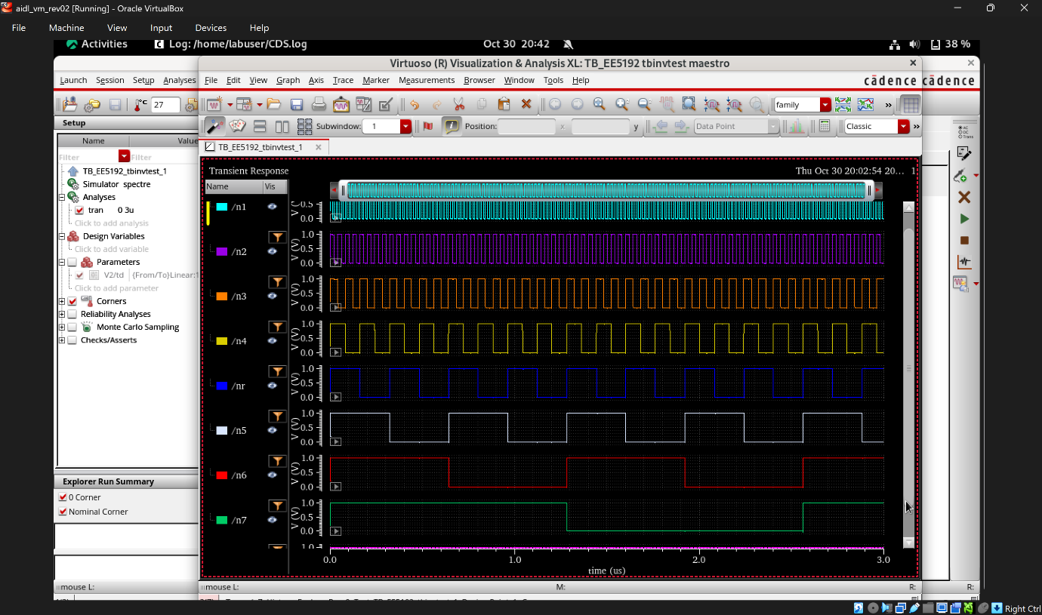

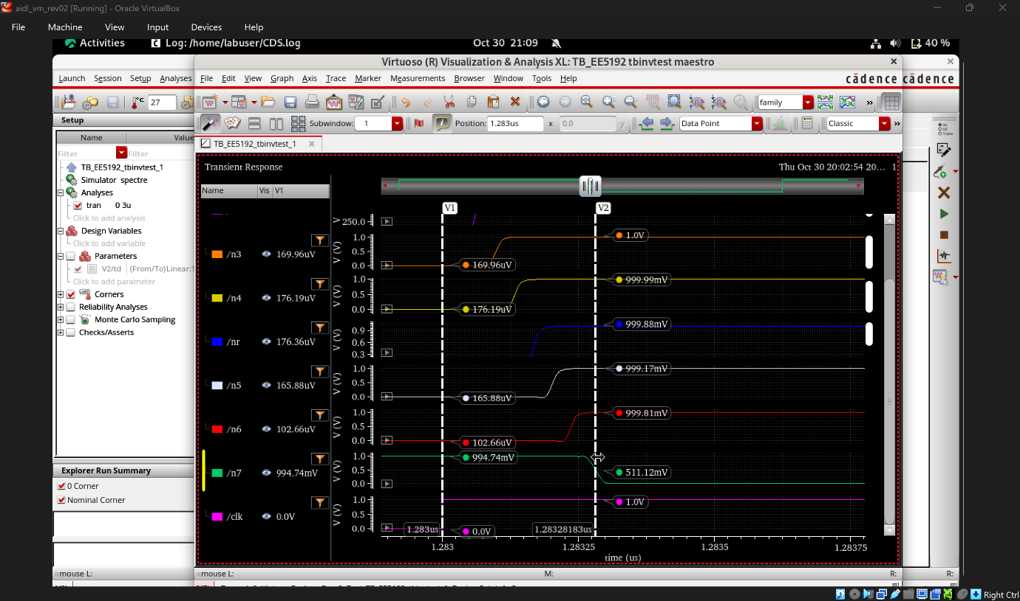
Propagation delay = 0.28183ns=3.5GHZ

